Sample Table: employees
CREATE TABLE t_employees(
c_emp_empid INT GENERATED ALWAYS AS IDENTITY(START WITH 1 INCREMENT BY 1),
c_emp_empname VARCHAR(50) NOT NULL,
c_emp_designation VARCHAR(50) NOT NULL,
c_emp_salary NUMERIC(12,2) NOT NULL CHECK(c_emp_salary>0),
c_emp_hiredate DATE NOT NULL,
c_emp_deptid INT NOT NULL,
c_emp_city VARCHAR(50) NOT NULL,
c_emp_email VARCHAR(50) NOT NULL,
c_emp_profile_data JSONB,
CONSTRAINT pk_emp PRIMARY KEY (c_emp_empid)
);

INSERT INTO t_employees(c_emp_empname,c_emp_designation,
c_emp_salary,c_emp_hiredate,c_emp_deptid,c_emp_city,c_emp_email,c_emp_profile_data)
VALUES
('Rajesh Kumar','Manager',90000,'2021-05-10',1, 'Mumbai', 'rajesh@example.com', '{"age":40,"skills":["Leadership","Finance"]}'),
('Anjali Sharma', 'Developer', 75000, '2022-08-15', 2, 'Delhi',
'anjali@example.com',
'{"age": 28, "skills": ["Java", "SQL"]}'),

('Vikram Patel', 'Analyst', 65000, '2020-11-20', 3, 'Bangalore',
'vikram@example.com',
'{"age": 35, "skills": ["Data Analysis", "Excel"]}'),

('Sneha Verma', 'HR Executive', 55000, '2023-02-01', 1, 'Kolkata',
'sneha@example.com',
'{"age": 30, "skills": ["Recruitment", "Communication"]}'),

('Manish Gupta', 'Sales Manager', 85000, '2019-06-25', 4, 'Chennai',
'manish@example.com',
'{"age": 45, "skills": ["Negotiation", "Marketing"]}'),

('Priya Singh', 'Developer', 72000, '2021-09-10', 2, 'Pune',
'priya@example.com',
'{"age": 26, "skills": ["Python", "Django"]}'),

('Arjun Mehta', 'Analyst', 60000, '2022-04-12', 3, 'Hyderabad',
'arjun@example.com',
'{"age": 32, "skills": ["SQL", "Reporting"]}'),

('Kavita Joshi', 'HR Manager', 75000, '2020-01-05', 1, 'Mumbai',
'kavita@example.com',
'{"age": 38, "skills": ["HR Policies", "Employee Relations"]}'),

('Rahul Nair', 'Developer', 78000, '2023-07-14', 2, 'Delhi',
'rahul@example.com',
'{"age": 29, "skills": ["React", "Node.js"]}'),

('Sunil Rao', 'Sales Executive', 62000, '2021-12-19', 4, 'Bangalore',
'sunil@example.com',
'{"age": 34, "skills": ["Client Handling", "CRM"]}');

Questions for LIMIT and OFFSET Queries (with FETCH also)
Q1 | Retrieve the first 5 employees based on hire date.
Query | SELECT * FROM t_employees ORDER BY c_emp_hiredate LIMIT 5
Output | 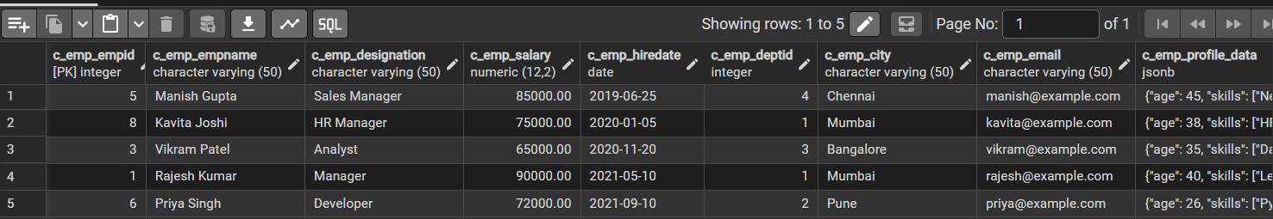

Q2 | Get the last 5 employees ordered by salary in descending order.
Query | SELECT * FROM t_employees ORDER BY c_emp_salary DESC OFFSET 5
Output | 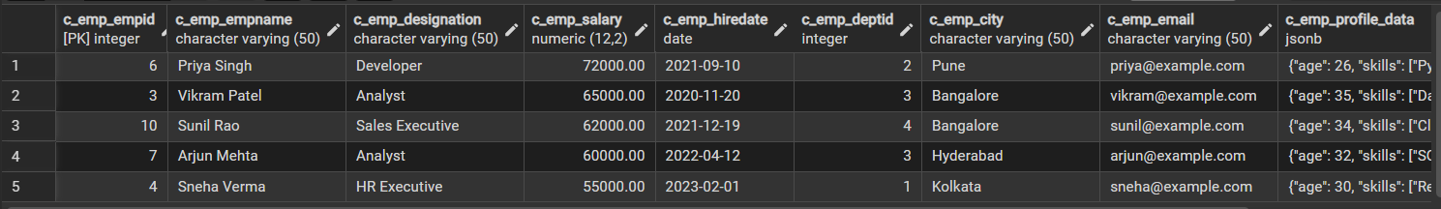

Q3 | Retrieve employees from position 6 to 10 ordered by empid.
Query | SELECT * FROM t_employees ORDER BY c_emp_empid LIMIT 5 OFFSET 5
Output | 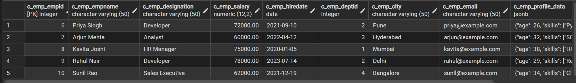

Q4 | Get the second page of 5 employees (assuming 5 employees per page).
Query | SELECT * FROM t_employees ORDER BY c_emp_empid LIMIT 5 OFFSET 5
Output | 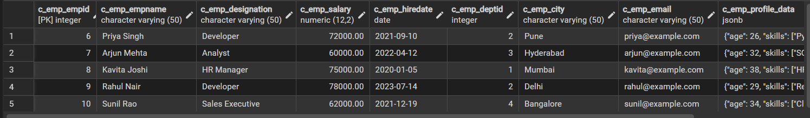

Q5 | List employees ranked 3 to 7 by hire date.
Query | SELECT * FROM t_employees ORDER BY c_emp_hiredate LIMIT 5 OFFSET 2
Output | 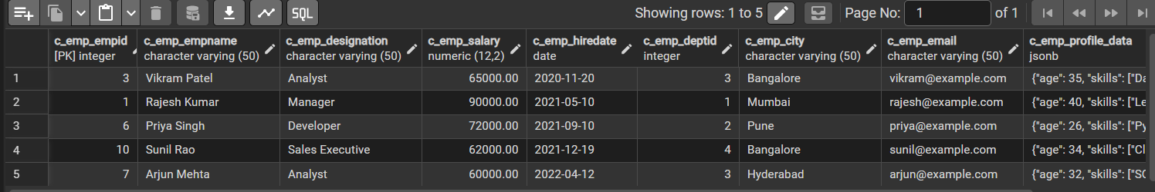

Q6 | Retrieve 4 employees from the middle of the dataset.
Query | SELECT * FROM t_employees ORDER BY c_emp_empid LIMIT 4 OFFSET 3
Output | 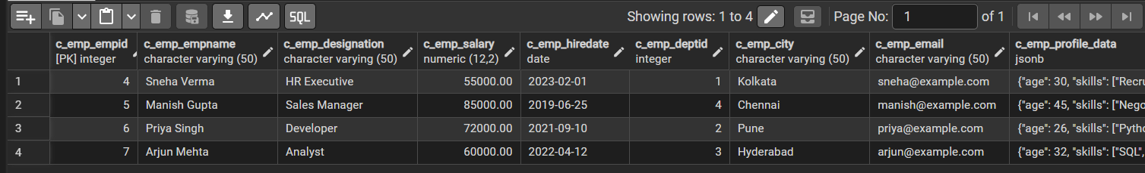

Q7 | Fetch employees with the highest salaries but return only the first 3 results.
Query | SELECT * FROM t_employees ORDER BY c_emp_salary DESC LIMIT 3
Output | 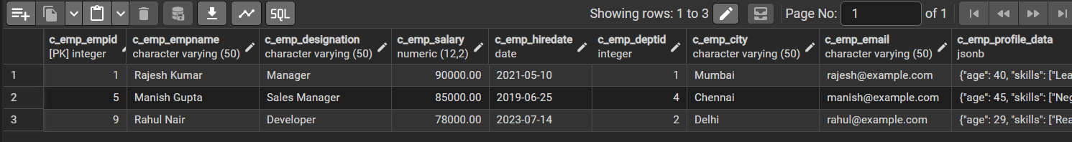

Q8 | Skip the first 2 employees and retrieve the next 4.
Query | SELECT * FROM t_employees ORDER BY c_emp_empid LIMIT 4 OFFSET 2
Output | 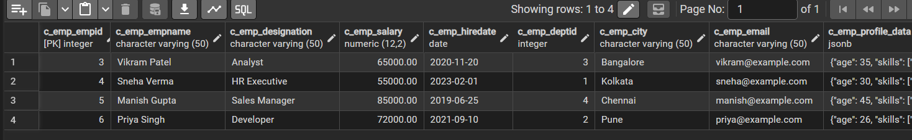

Q9 | Get the top 5 youngest employees by extracting age from the JSON column.
Query | SELECT * FROM t_employees ORDER BY (c_emp_profile_data ->> 'age')::INT ASC LIMIT 5
Output | 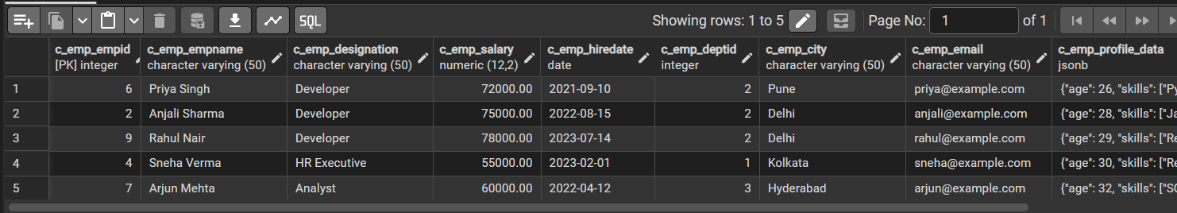

Q10 | Retrieve employees with a salary greater than 60,000 but limit the output to 5 employees.
Query | SELECT * FROM t_employees WHERE c_emp_salary > 60000 ORDER BY c_emp_empid LIMIT 5
Output | 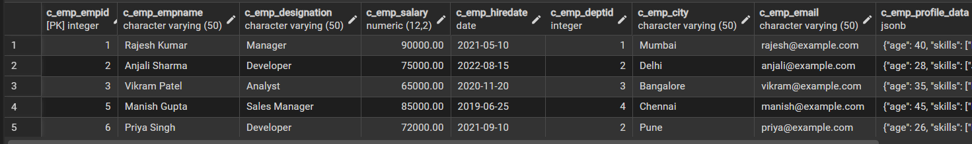

Questions for Saving and Querying JSON Data from the Database
Q1 | Save JSON Data: How do you insert an employee’s profile details (age, skills) into a JSON column?
Query | INSERT INTO t_employees(c_emp_empname,c_emp_designation,  c_emp_salary,c_emp_hiredate,c_emp_deptid,  c_emp_city,c_emp_email,c_emp_profile_data)  VALUES  (  'Rahul Patel',  'Developer',  70000,  '2024-01-15',  2,  'Surat',  'rahul@example.com',  '{"age": 27, "skills": ["Java", "SQL"]}'::json  );
Output | 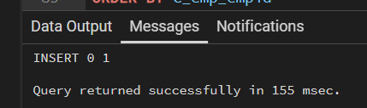

Q2 | Retrieve JSON Data: How do you extract only the employee names and skills from the JSON column?
Query | SELECT c_emp_empname, c_emp_profile_data ->'skills'"skills" FROM t_employees
Output | 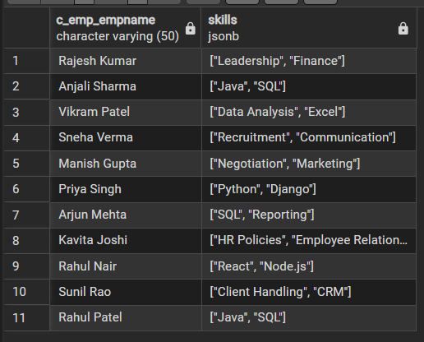

Q3 | Filter by JSON Field: Write a query to find employees whose JSON profile has "Python" in the skills list.
Query | SELECT * FROM t_employees  WHERE c_emp_profile_data->'skills' @>'["Python"]'
Output

Q4 | Update JSON Data: How do you add a new skill (e.g., "AI") to an employee’s profile data?
Query | UPDATE t_employees  SET c_emp_profile_data = jsonb_set(  c_emp_profile_data,  '{skills}',  (c_emp_profile_data->'skills') || '"Ai"'  )  WHERE c_emp_empid = 2;
Output | 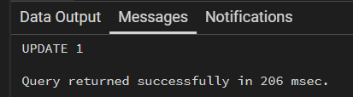

Q5 | Search by Age: Write a query to find employees whose JSON profile age is greater than 30
Query | SELECT * FROM t_employees  WHERE (c_emp_profile_data->>'age')::INT > 30
Output | 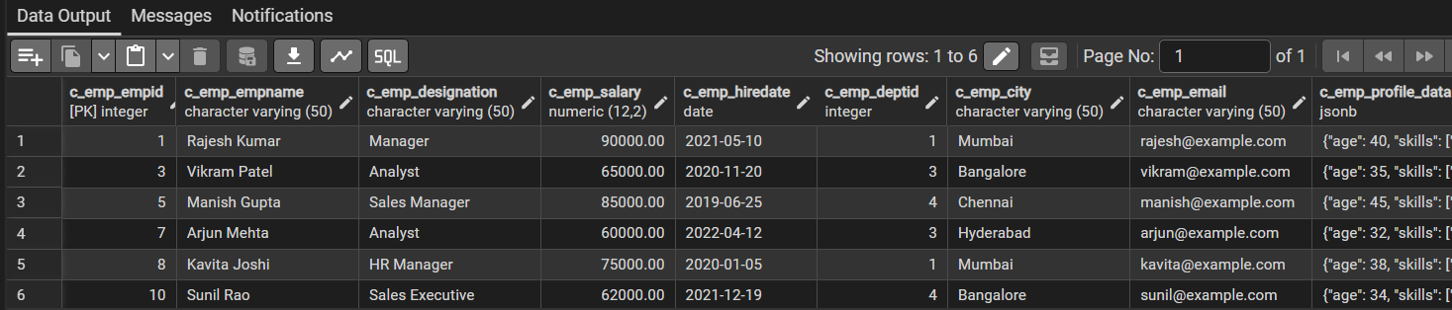

Q6 | Count JSON Entries: How do you count the number of employees who have more than 2 skills listed in their JSON profile?
Query | SELECT * FROM t_employees  WHERE jsonb_array_length(c_emp_profile_data->'skills')> 2
Output | 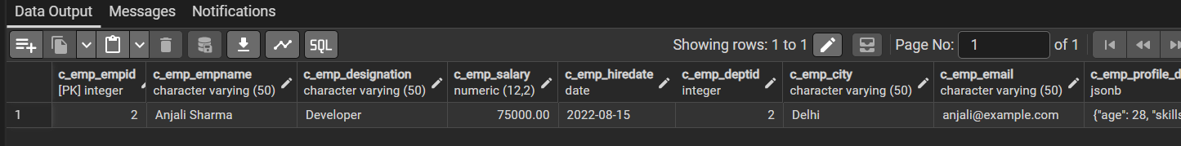

Q7 | Retrieve JSON as Text: Write a query to extract and display the JSON field as a formatted text column
Query | SELECT c_emp_empid, c_emp_profile_data::TEXT  FROM t_employees
Output | 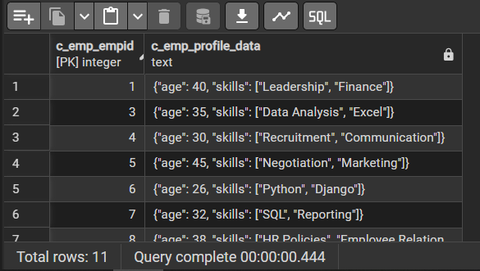

Q8 | Sorting by JSON Field: How do you sort employees by age stored inside the JSON column?
Query | SELECT c_emp_empid, c_emp_profile_data::TEXT  FROM t_employees  ORDER BY (c_emp_profile_data -> 'age')::INT ASC
Output | 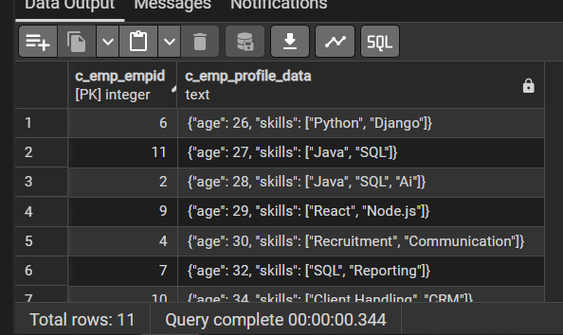

Q9 | Find Employees Without Skills: Retrieve employees whose JSON profile does not contain any skills.
Query | SELECT c_emp_empid, c_emp_profile_data::TEXT  FROM t_employees  WHERE c_emp_profile_data -> 'skills' IS NULL
Output | 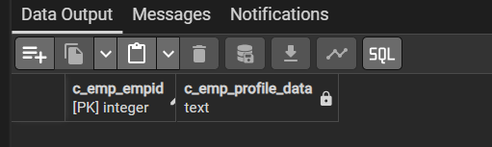

Q10 | Extract Nested JSON Values: How do you fetch only the first skill from the skills array inside the JSON field?
Query | SELECT c_emp_empid, c_emp_profile_data->'skills'->>0"first_skill"  FROM t_employees
Output | 